Cone-Based Subtraction

Definition
# Source: AI Source: Provided by: [Data Path: Persons Table -> ID Column: 1, Name_En Column: Motasem Essam] -> From: [ChatGPT] on [7/25/2026]
Cone-Based Subtraction is a type of composite solid formation in which one or more portions are removed from an original cone or a cone-based solid to create cavities, holes, notches, grooves, or other cutout shapes.
The removed portions may have the shape of cones, cylinders, prisms, pyramids, spheres, or other geometric solids.
The resulting object is called a cone-based solid formed by subtraction.

Simple Definition
# Source: AI Source: Provided by: [Data Path: Persons Table -> ID Column: 1, Name_En Column: Motasem Essam] -> From: [ChatGPT] on [7/25/2026]
Cone-Based Subtraction means removing a geometric portion from a cone-shaped solid to create a new shape.
Example: Removing a smaller cone from a larger cone to produce a hollow or truncated interior.

Geometric Representation
# Source: AI Source: Provided by: [Data Path: Persons Table -> ID Column: 1, Name_En Column: Motasem Essam] -> From: [ChatGPT] on [7/25/2026]
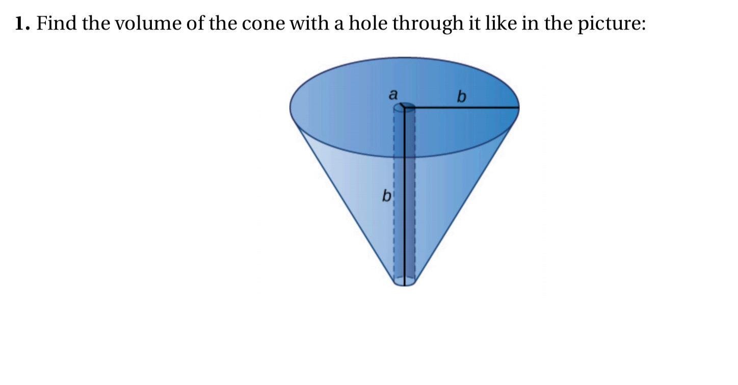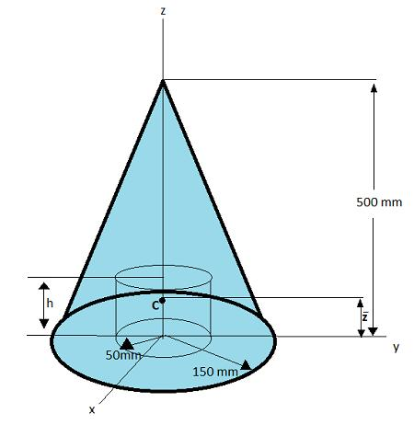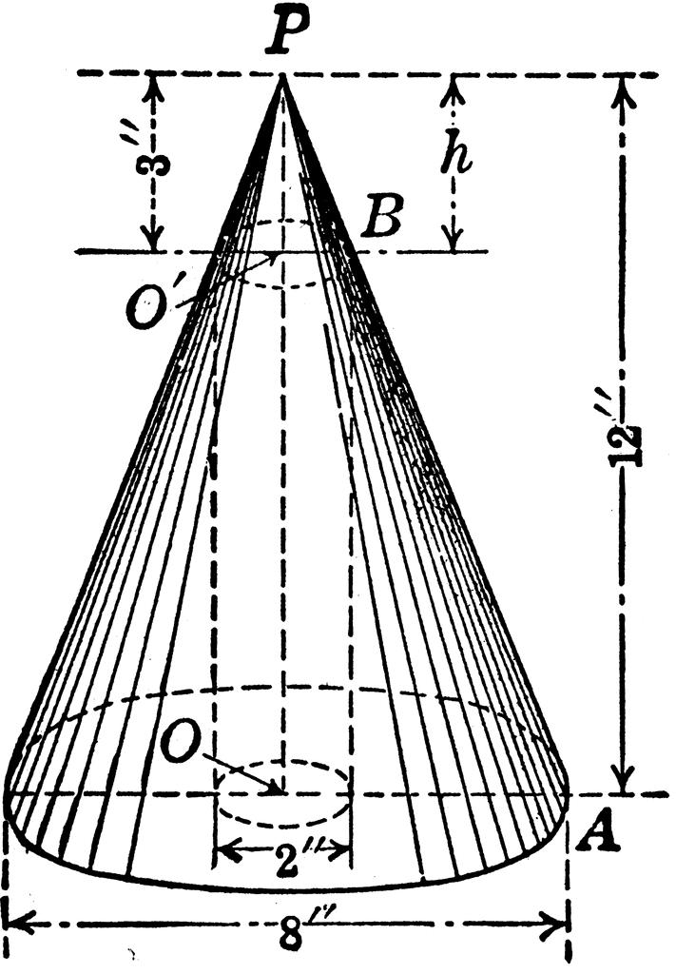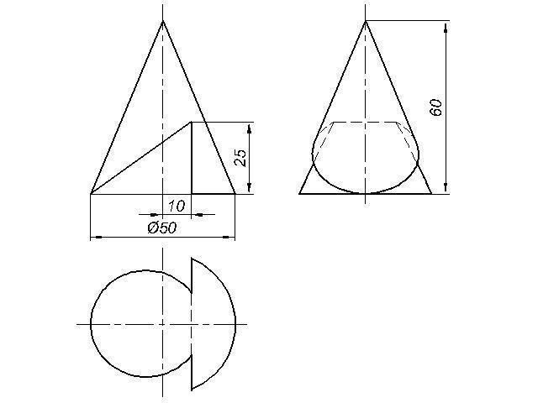

Main Components
# Source: AI Source: Provided by: [Data Path: Persons Table -> ID Column: 1, Name_En Column: Motasem Essam] -> From: [ChatGPT] on [7/25/2026]
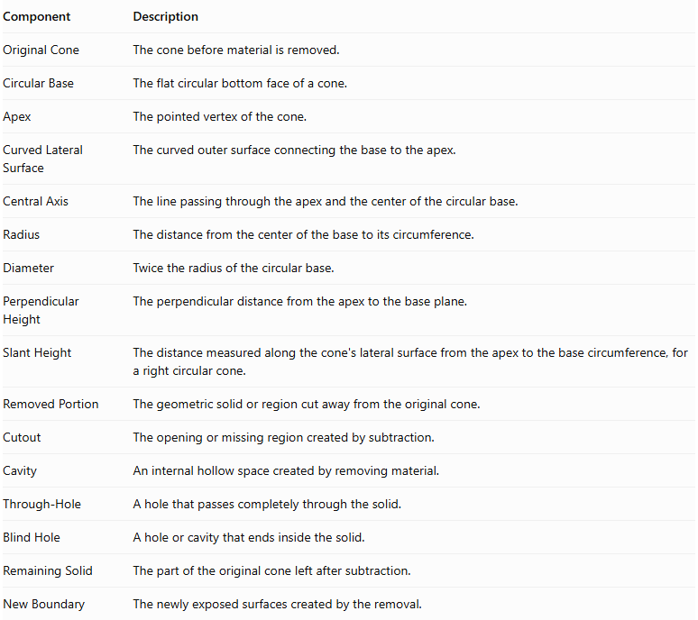
Component | Description
Original Cone | The cone before material is removed.
Circular Base | The flat circular bottom face of a cone.
Apex | The pointed vertex of the cone.
Curved Lateral Surface | The curved outer surface connecting the base to the apex.
Central Axis | The line passing through the apex and the center of the circular base.
Radius | The distance from the center of the base to its circumference.
Diameter | Twice the radius of the circular base.
Perpendicular Height | The perpendicular distance from the apex to the base plane.
Slant Height | The distance measured along the cone's lateral surface from the apex to the base circumference, for a right circular cone.
Removed Portion | The geometric solid or region cut away from the original cone.
Cutout | The opening or missing region created by subtraction.
Cavity | An internal hollow space created by removing material.
Through-Hole | A hole that passes completely through the solid.
Blind Hole | A hole or cavity that ends inside the solid.
Remaining Solid | The part of the original cone left after subtraction.
New Boundary | The newly exposed surfaces created by the removal.

Types of Cone-Based Subtraction

Conical Subtraction from a Cone
# Source: AI Source: Provided by: [Data Path: Persons Table -> ID Column: 1, Name_En Column: Motasem Essam] -> From: [ChatGPT] on [7/25/2026]
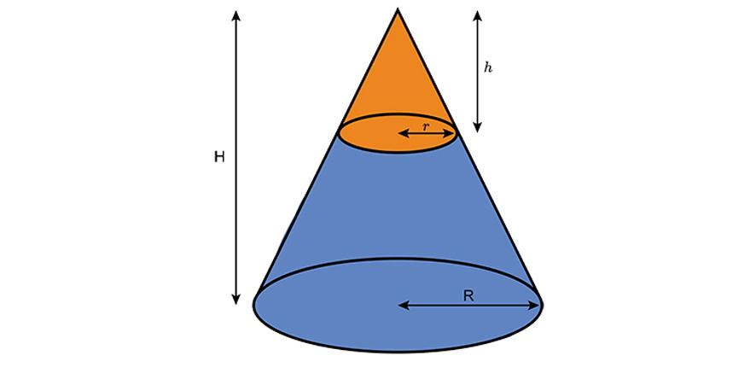
A smaller conical portion is removed from a larger cone.
Examples:
- Coaxial conical cavity.
- Off-center conical cavity.
- Conical through-hole.
- Conical blind cavity.
- Inverted conical cavity.

Cylindrical Subtraction from a Cone
# Source: AI Source: Provided by: [Data Path: Persons Table -> ID Column: 1, Name_En Column: Motasem Essam] -> From: [ChatGPT] on [7/25/2026]
A cylindrical portion is removed from a cone.
Examples:
- Central cylindrical hole.
- Off-center cylindrical hole.
- Vertical cylindrical cavity.
- Horizontal cylindrical tunnel.
- Cylindrical blind hole.

Rectangular Prism Subtraction from a Cone
# Source: AI Source: Provided by: [Data Path: Persons Table -> ID Column: 1, Name_En Column: Motasem Essam] -> From: [ChatGPT] on [7/25/2026]
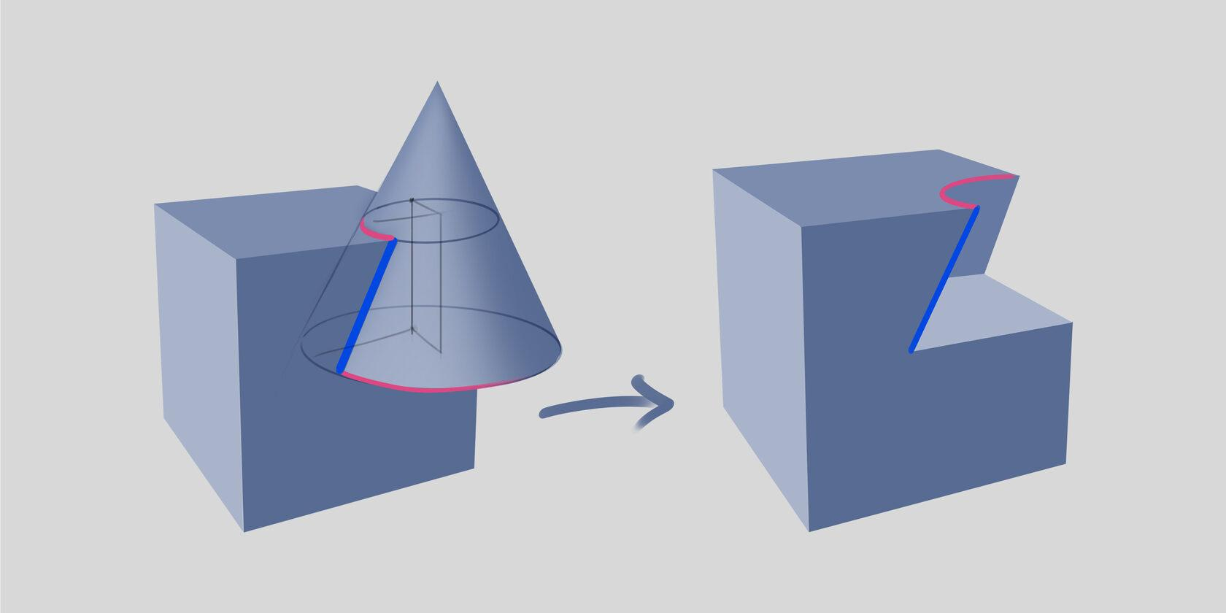
A rectangular-prism-shaped portion is removed from a cone.
Examples:
- Rectangular notch.
- Rectangular cavity.
- Rectangular slot.
- Rectangular through-cut.
- Rectangular side opening.

Triangular Prism Subtraction from a Cone
# Source: AI Source: Provided by: [Data Path: Persons Table -> ID Column: 1, Name_En Column: Motasem Essam] -> From: [ChatGPT] on [7/25/2026]
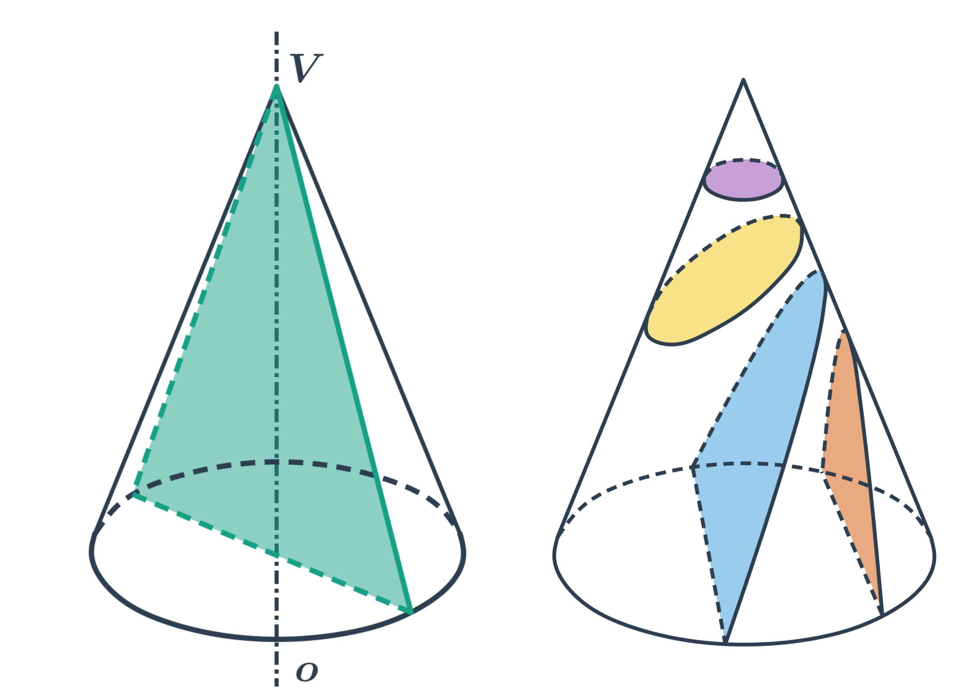
A triangular-prism-shaped portion is removed from a cone.
Examples:
- Triangular notch.
- Wedge-shaped cutout.
- Triangular cavity.
- Triangular side opening.

Pyramidal Subtraction from a Cone
# Source: AI Source: Provided by: [Data Path: Persons Table -> ID Column: 1, Name_En Column: Motasem Essam] -> From: [ChatGPT] on [7/25/2026]
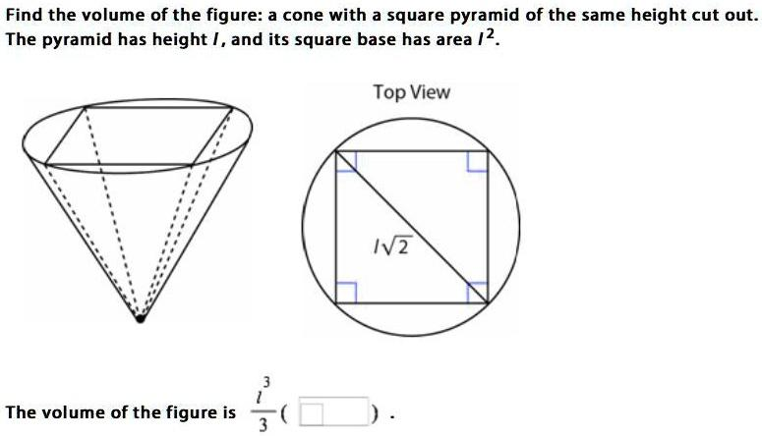
A pyramidal portion is removed from a cone.
Examples:
- Square-pyramidal cavity.
- Triangular-pyramidal cavity.
- Central pyramidal cutout.
- Off-center pyramidal cutout.

Spherical Subtraction from a Cone
# Source: AI Source: Provided by: [Data Path: Persons Table -> ID Column: 1, Name_En Column: Motasem Essam] -> From: [ChatGPT] on [7/25/2026]
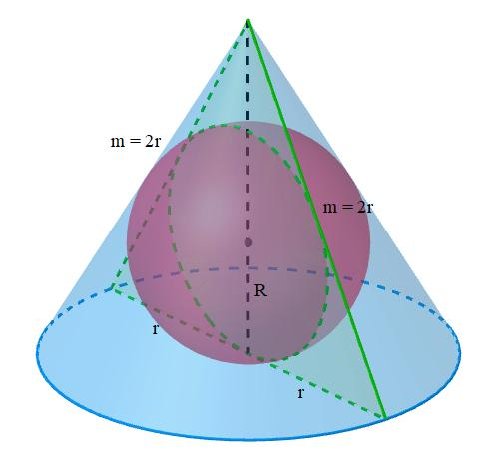
A spherical portion is removed from a cone.
Examples:
- Spherical cavity.
- Partial spherical depression.
- Spherical through-opening.
- Off-center spherical cutout.

Multiple-Shape Subtraction from a Cone
# Source: AI Source: Provided by: [Data Path: Persons Table -> ID Column: 1, Name_En Column: Motasem Essam] -> From: [ChatGPT] on [7/25/2026]
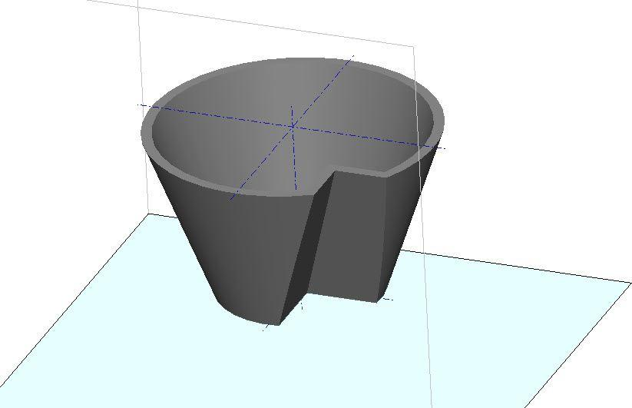
Two or more portions are removed from the same cone.
Examples:
- Multiple cylindrical holes.
- Conical cavity with cylindrical hole.
- Rectangular notch with spherical cavity.
- Multiple mixed-shape cutouts.

Classification by Location of Subtraction
# Source: AI Source: Provided by: [Data Path: Persons Table -> ID Column: 1, Name_En Column: Motasem Essam] -> From: [ChatGPT] on [7/25/2026]
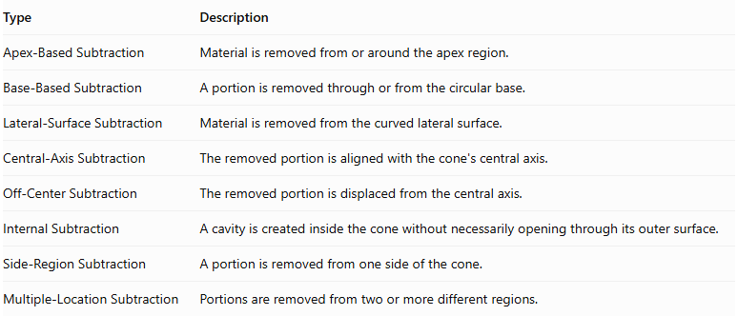
Type | Description
Apex-Based Subtraction | Material is removed from or around the apex region.
Base-Based Subtraction | A portion is removed through or from the circular base.
Lateral-Surface Subtraction | Material is removed from the curved lateral surface.
Central-Axis Subtraction | The removed portion is aligned with the cone's central axis.
Off-Center Subtraction | The removed portion is displaced from the central axis.
Internal Subtraction | A cavity is created inside the cone without necessarily opening through its outer surface.
Side-Region Subtraction | A portion is removed from one side of the cone.
Multiple-Location Subtraction | Portions are removed from two or more different regions.

Classification by Subtraction Method
# Source: AI Source: Provided by: [Data Path: Persons Table -> ID Column: 1, Name_En Column: Motasem Essam] -> From: [ChatGPT] on [7/25/2026]
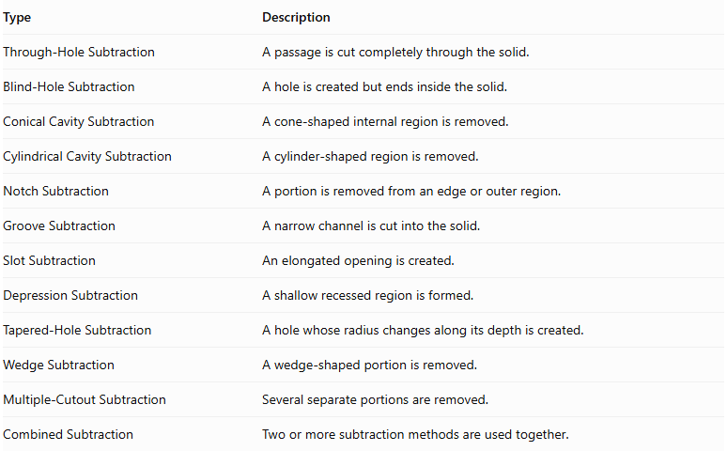
Type | Description
Through-Hole Subtraction | A passage is cut completely through the solid.
Blind-Hole Subtraction | A hole is created but ends inside the solid.
Conical Cavity Subtraction | A cone-shaped internal region is removed.
Cylindrical Cavity Subtraction | A cylinder-shaped region is removed.
Notch Subtraction | A portion is removed from an edge or outer region.
Groove Subtraction | A narrow channel is cut into the solid.
Slot Subtraction | An elongated opening is created.
Depression Subtraction | A shallow recessed region is formed.
Tapered-Hole Subtraction | A hole whose radius changes along its depth is created.
Wedge Subtraction | A wedge-shaped portion is removed.
Multiple-Cutout Subtraction | Several separate portions are removed.
Combined Subtraction | Two or more subtraction methods are used together.

Classification by Number and Arrangement
# Source: AI Source: Provided by: [Data Path: Persons Table -> ID Column: 1, Name_En Column: Motasem Essam] -> From: [ChatGPT] on [7/25/2026]
- Single Subtraction: One portion is removed from the cone.
- Double Subtraction: Two portions are removed.
- Multiple Subtraction: Three or more portions are removed.
- Repeated Subtraction: Similar cutouts are repeated in different locations.
- Axial Subtraction: The removed portions are aligned with the cone's central axis.
- Radial Subtraction: Cutouts are arranged around the central axis.
- Symmetrical Subtraction: Removed portions are arranged symmetrically.
- Asymmetrical Subtraction: Removed portions are arranged without symmetry.
- Uniform Subtraction: Repeated cutouts have consistent dimensions and spacing.
- Non-Uniform Subtraction: Cutouts differ in dimensions or spacing.
- Mixed-Shape Subtraction: Different geometric shapes are removed from the same cone.

Mathematical Properties and Formulas

Volume of the Original Cone
# Source: AI Source: Provided by: [Data Path: Persons Table -> ID Column: 1, Name_En Column: Motasem Essam] -> From: [ChatGPT] on [7/25/2026]
For a right circular cone:
$$V_{cone}=\frac{1}{3}πR^{2}H$$
Where:
- $R$ = original base radius.
- $H$ = perpendicular height.
- $π≈3.14159$.

Surface Area of the Original Cone
# Source: AI Source: Provided by: [Data Path: Persons Table -> ID Column: 1, Name_En Column: Motasem Essam] -> From: [ChatGPT] on [7/25/2026]
The total surface area is:
$${SA}_{cone}=πR^{2}+πRl$$
The curved lateral surface area is:
$${LSA}_{cone}=πRl$$
For a right circular cone, the slant height is:
$$l=\sqrt{R^{2}+H^{2}}$$

Remaining Volume After Subtraction
# Source: AI Source: Provided by: [Data Path: Persons Table -> ID Column: 1, Name_En Column: Motasem Essam] -> From: [ChatGPT] on [7/25/2026]
$$V_{remaining}=V_{original}-V_{removed}$$
For multiple non-overlapping removed portions:
$$V_{remaining}=V_{original}-\sum_{i=1}^{n}{V_{i}}$$
If removed portions overlap, their intersection must not be subtracted twice.

Volume of Common Removed Shapes
# Source: AI Source: Provided by: [Data Path: Persons Table -> ID Column: 1, Name_En Column: Motasem Essam] -> From: [ChatGPT] on [7/25/2026]
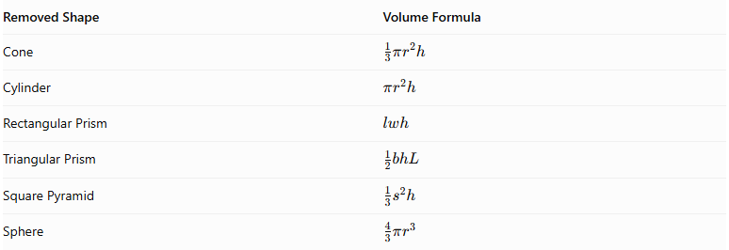
Removed Shape | Volume Formula
Cone | $$\frac{1}{3}πr^{2}h$$
Cylinder | $$πr^{2}h$$
Rectangular Prism | $$lwh$$
Triangular Prism | $$\frac{1}{2}bhL$$
Square Pyramid | $$\frac{1}{3}s^{2}h$$
Sphere | $$\frac{4}{3}πr^{3}$$
Here, $r$ is the removed shape's radius, $h$ its perpendicular height, $L$ its prism length, and $s$ the square pyramid's base side.

Surface Area After Subtraction
# Source: AI Source: Provided by: [Data Path: Persons Table -> ID Column: 1, Name_En Column: Motasem Essam] -> From: [ChatGPT] on [7/25/2026]
Surface area must be calculated by considering the surfaces that remain exposed and the new surfaces created by the cut.
$${SA}_{remaining}={SA}_{original}-{SA}_{removed boundary}+{SA}_{newly exposed}$$
This is a conceptual accounting formula: only the portions of the original boundary that disappear are subtracted, and only the newly exposed cavity or cut surfaces are added.
Important: The surface area of the removed solid is not automatically the area to subtract. The shape and position of the cut determine which surfaces are removed and which new surfaces are exposed.

Worked Examples

Example 1: Cone with a Conical Blind Cavity
# Source: AI Source: Provided by: [Data Path: Persons Table -> ID Column: 1, Name_En Column: Motasem Essam] -> From: [ChatGPT] on [7/25/2026]
Given:
- Original cone radius: $R=6 cm$
- Original cone height: $H=8 cm$
- Removed conical cavity radius: $r=2 cm$
- Cavity depth: $d=4 cm$
Step 1: Calculate the original cone volume.
$$V_{original}=\frac{1}{3}π(6)^{2}(8)=96π$$
$$V_{original}≈301.59{ cm}^{3}$$
Step 2: Calculate the removed cone volume.
$$V_{removed}=\frac{1}{3}π(2)^{2}(4)=\frac{16π}{3}$$
Correction: the removed volume is $\frac{16π}{3}$, not $16π$.
Step 3: Calculate the remaining volume.
$$V_{remaining}=96π-\frac{16π}{3}=\frac{272π}{3}$$
$$\boxed{V_{remaining}≈284.84{ cm}^{3}}$$
Step 4: Calculate the original cone surface area.
The original slant height is:
$$l=\sqrt{6^{2}+8^{2}}=10$$
$${SA}_{original}=π(6)^{2}+π(6)(10)=96π$$
Step 5: Calculate the new surface area.
The cavity's slant height is:
$$s=\sqrt{2^{2}+4^{2}}=\sqrt{20}=2\sqrt{5}$$
- Original base area removed: $4π$.
- New cavity curved area: $π(2)(2\sqrt{5})=4π\sqrt{5}$.
$${SA}_{remaining}=96π-4π+4π\sqrt{5}$$
$$\boxed{{SA}_{remaining}≈317.13{ cm}^{2}}$$
Conclusion: The conical cavity reduces the cone's volume and creates a new internal curved surface.

Example 2: Cone with a Cylindrical Blind Hole
# Source: AI Source: Provided by: [Data Path: Persons Table -> ID Column: 1, Name_En Column: Motasem Essam] -> From: [ChatGPT] on [7/25/2026]
Given:
- Original cone radius: $R=5 cm$
- Original cone height: $H=12 cm$
- Cylindrical hole radius: $r=1 cm$
- Hole depth: $d=6 cm$
Step 1: Calculate the original cone volume.
$$V_{original}=\frac{1}{3}π(5)^{2}(12)=100π$$
Step 2: Calculate the removed cylinder volume.
$$V_{removed}=π(1)^{2}(6)=6π$$
Step 3: Calculate the remaining volume.
$$V_{remaining}=100π-6π=94π$$
$$\boxed{V_{remaining}≈295.31{ cm}^{3}}$$
Step 4: Calculate the original cone surface area.
$$l=\sqrt{5^{2}+{12}^{2}}=13$$
$${SA}_{original}=π(5)^{2}+π(5)(13)=90π$$
Step 5: Calculate the new surface area.
The circular opening at the base and the circular bottom of the blind hole have equal areas, so these areas cancel each other.
The new cylindrical inner wall has area:
$$A_{inner}=2πrd=2π(1)(6)=12π$$
$${SA}_{remaining}=90π+12π$$
$$\boxed{{SA}_{remaining}=102π≈320.44{ cm}^{2}}$$
Conclusion: The cylindrical hole reduces the cone's volume and adds an internal cylindrical surface.

Important Characteristics
# Source: AI Source: Provided by: [Data Path: Persons Table -> ID Column: 1, Name_En Column: Motasem Essam] -> From: [ChatGPT] on [7/25/2026]
- Cone-Based Structure: The original solid is a cone or a composite solid containing a cone.
- Material Removal: One or more geometric portions are removed from the original solid.
- Volume Reduction: The remaining volume is smaller than the original volume.
- Surface Modification: New internal or external surfaces may appear after subtraction.
- Variable Cutout Shapes: Removed portions can be conical, cylindrical, rectangular, triangular, pyramidal, spherical, or mixed.
- Different Cutout Locations: Subtraction can occur at the apex, base, curved surface, or interior.
- Symmetrical or Asymmetrical Design: Cutouts may be aligned with the central axis or positioned off-center.
- Complex Geometric Results: Multiple subtraction operations can produce complicated solid shapes.

Comparison with Other Subtraction Types
# Source: AI Source: Provided by: [Data Path: Persons Table -> ID Column: 1, Name_En Column: Motasem Essam] -> From: [ChatGPT] on [7/25/2026]
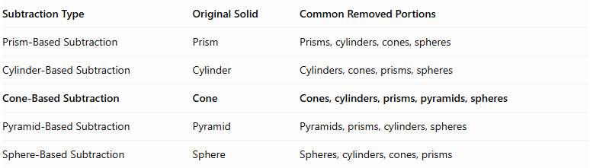
Subtraction Type | Original Solid | Common Removed Portions
Prism-Based Subtraction | Prism | Prisms, cylinders, cones, spheres
Cylinder-Based Subtraction | Cylinder | Cylinders, cones, prisms, spheres
Cone-Based Subtraction | Cone | Cones, cylinders, prisms, pyramids, spheres
Pyramid-Based Subtraction | Pyramid | Pyramids, prisms, cylinders, spheres
Sphere-Based Subtraction | Sphere | Spheres, cylinders, cones, prisms

Applications
# Source: AI Source: Provided by: [Data Path: Persons Table -> ID Column: 1, Name_En Column: Motasem Essam] -> From: [ChatGPT] on [7/25/2026]
- Mechanical Engineering: Designing tapered cavities, hollow components, and specialized mechanical parts.
- Manufacturing: Creating conical openings, recessed areas, and tapered holes.
- Automotive Engineering: Producing conical seats, tapered recesses, and specialized component openings.
- Construction: Designing architectural components with recessed or hollow conical structures.
- Product Design: Creating decorative and functional conical objects.
- CAD Modeling: Constructing complex three-dimensional objects using Boolean subtraction operations.
- Education: Teaching volume subtraction, surface area, and three-dimensional geometric transformations.

Key Points
# Source: AI Source: Provided by: [Data Path: Persons Table -> ID Column: 1, Name_En Column: Motasem Essam] -> From: [ChatGPT] on [7/25/2026]
- Cone-Based Subtraction removes one or more geometric portions from an original cone.
- The removed portions can have different geometric shapes.
- Subtraction can produce holes, cavities, notches, grooves, slots, and depressions.
- The removed portion's volume is subtracted from the original volume.
- Surface area must account for the original surfaces removed and the newly exposed surfaces.
- A blind hole creates an internal bottom surface, while a through-hole passes completely through the solid.
- The position, dimensions, and shape of each cutout determine the final geometry.

Conclusion
# Source: AI Source: Provided by: [Data Path: Persons Table -> ID Column: 1, Name_En Column: Motasem Essam] -> From: [ChatGPT] on [7/25/2026]
Cone-Based Subtraction is a method of forming composite solids by removing one or more geometric portions from an original cone. It can produce simple hollow cones as well as complex shapes containing cavities, holes, grooves, and multiple cutouts.
Its mathematical analysis involves calculating the remaining volume and identifying all exposed surfaces after subtraction. It is an important concept in solid geometry, engineering, manufacturing, and three-dimensional modeling.

